

**PROJECT GROUP MEMBER**

|  |  |
| --- | --- |
| **Students Id** | **Students Name** |
| ***Student1391568*** | ***Syed Muhammad Arham*** |
| ***Student1421636*** | ***Muhammad Anas*** |
| ***Student1425430*** | ***Muhammad Talha*** |
| ***Student1449759*** | ***Muhammad Hassan*** |
| ***Student1413553*** | ***Murtaza Mustafa*** |

**CURRICULUM BATCH**

**7062 2301C2**

**FACULTY**

**SIR HARIS NASEER**

**CO-ORDINATOR**

**MISS MAHA HAIDER**

**ADMIN REGISTER**

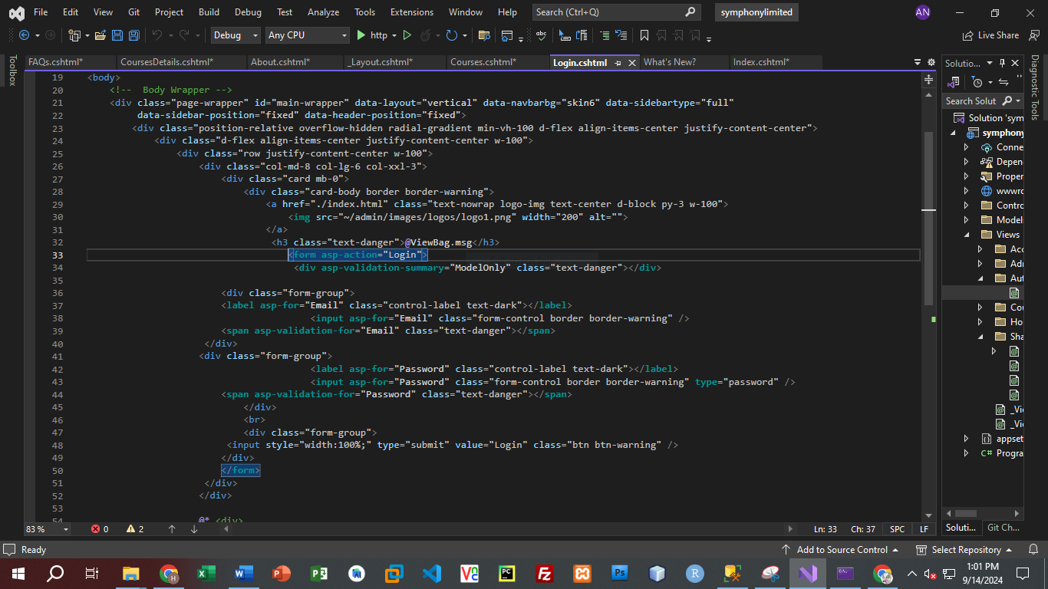

**ADD COURSE FORM**

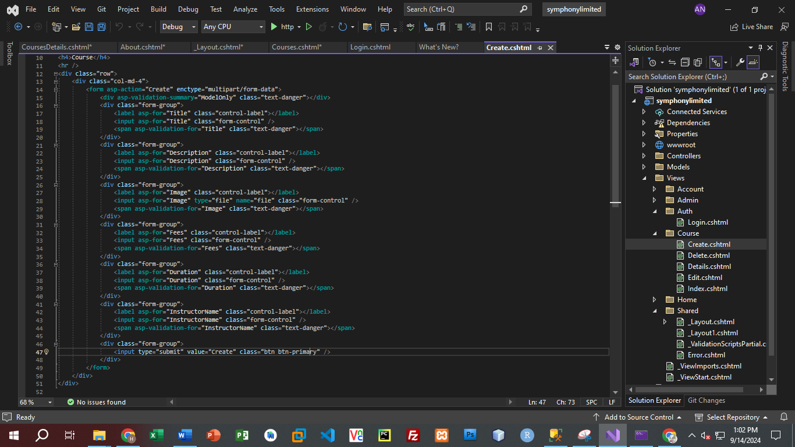

**FEE RECORD**

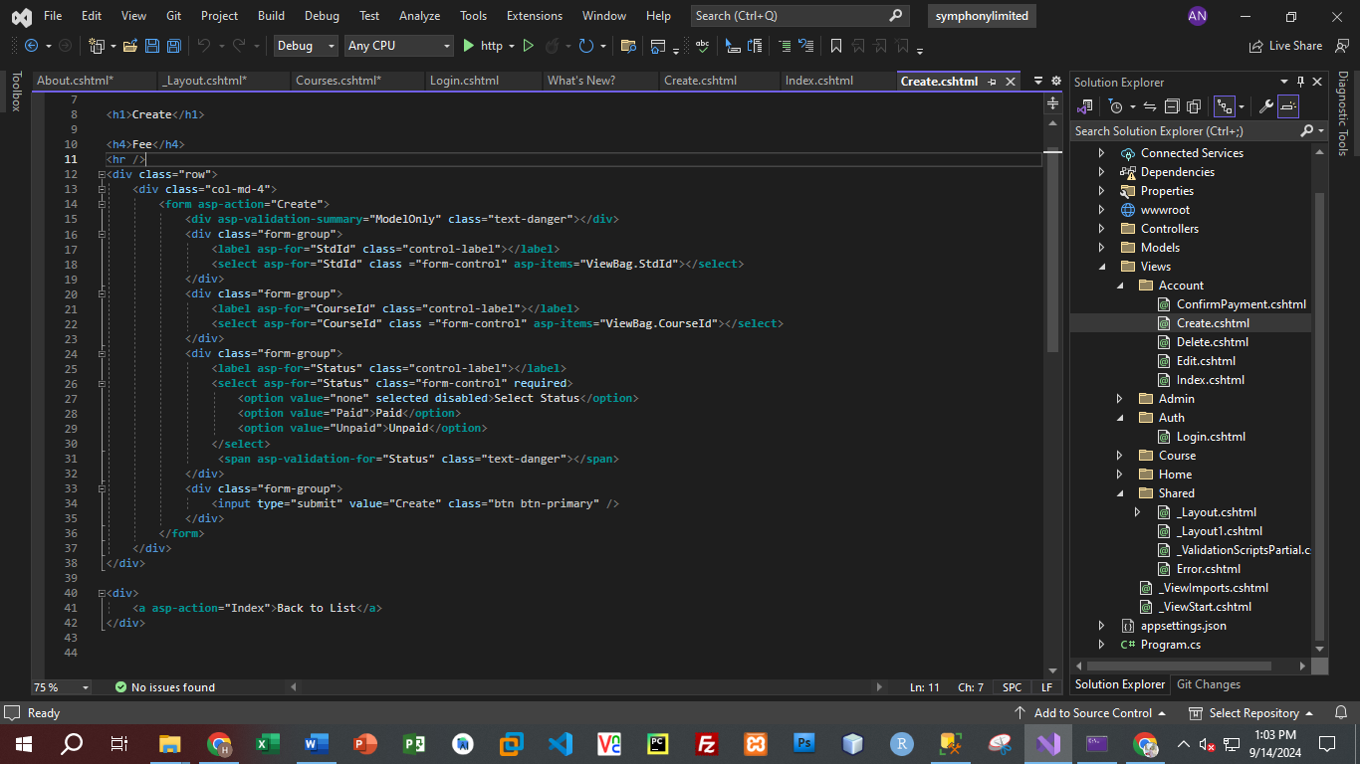

**REGISTER**

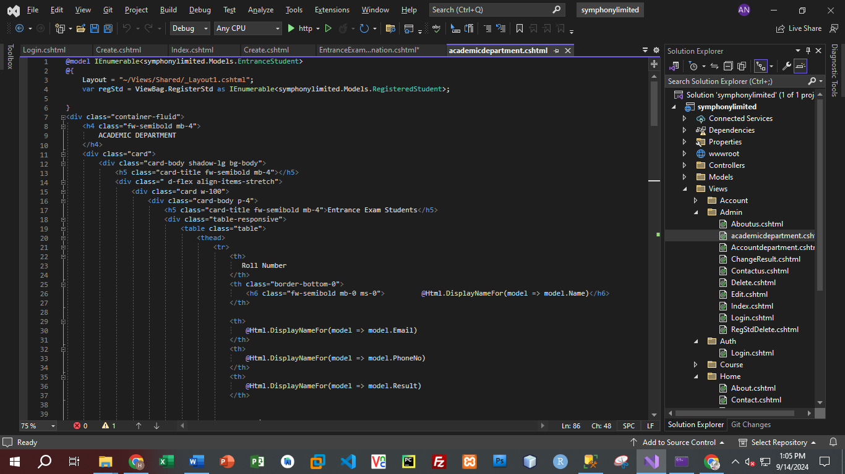

**HOME**

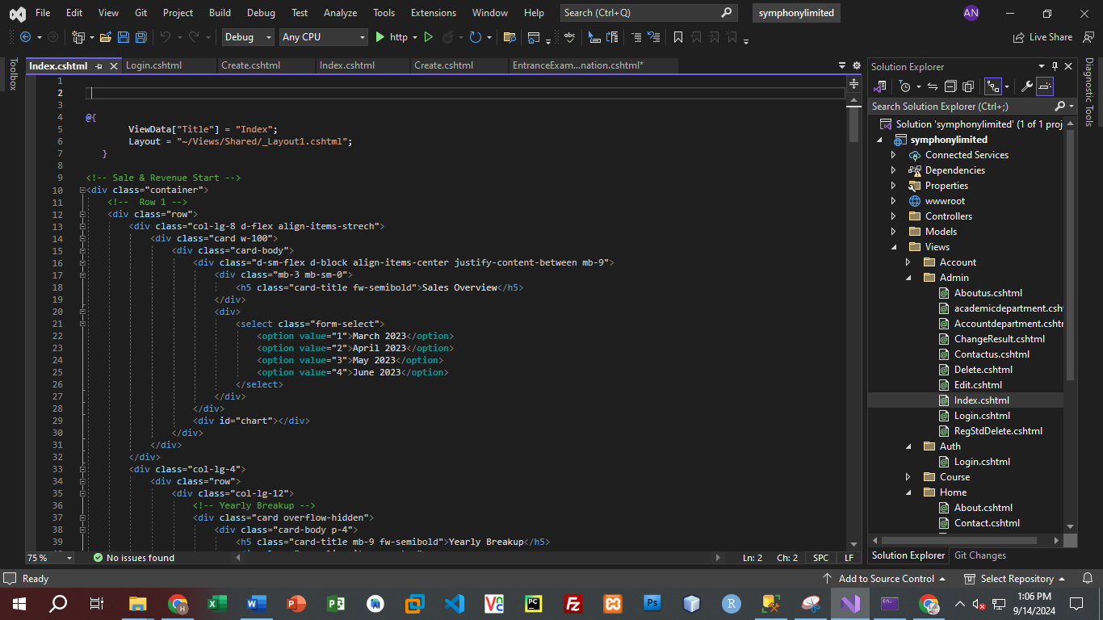

**ABOUT**

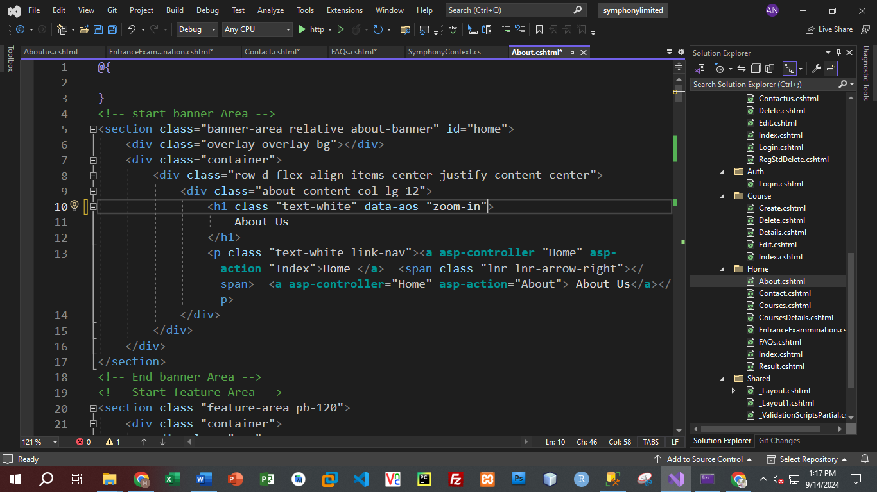

**COURSE**

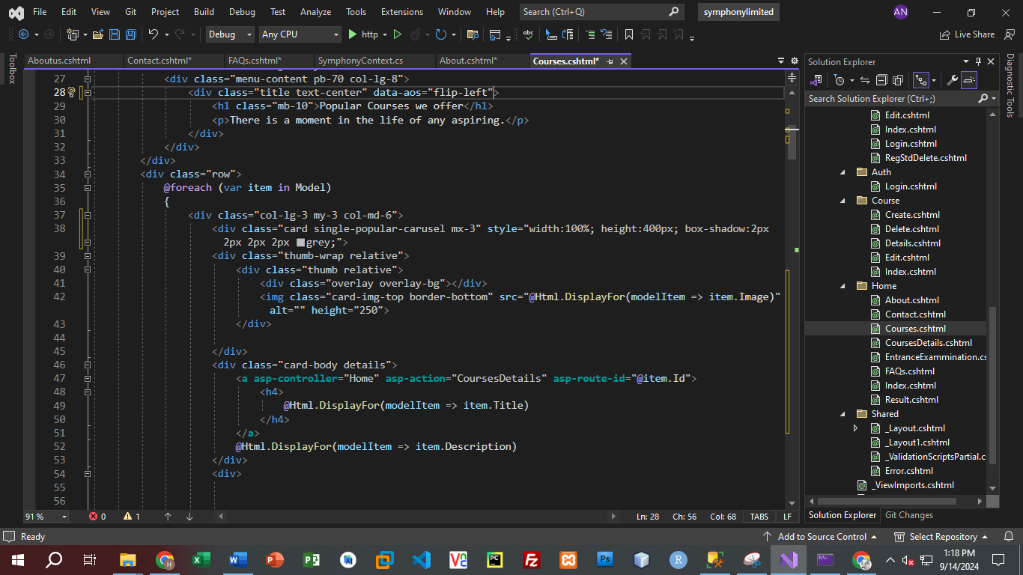

**COURSE-DETAIL**

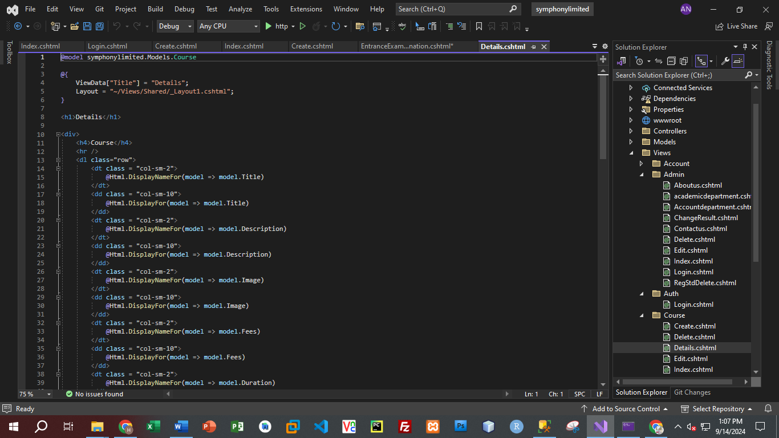

**ENTER EXAM**

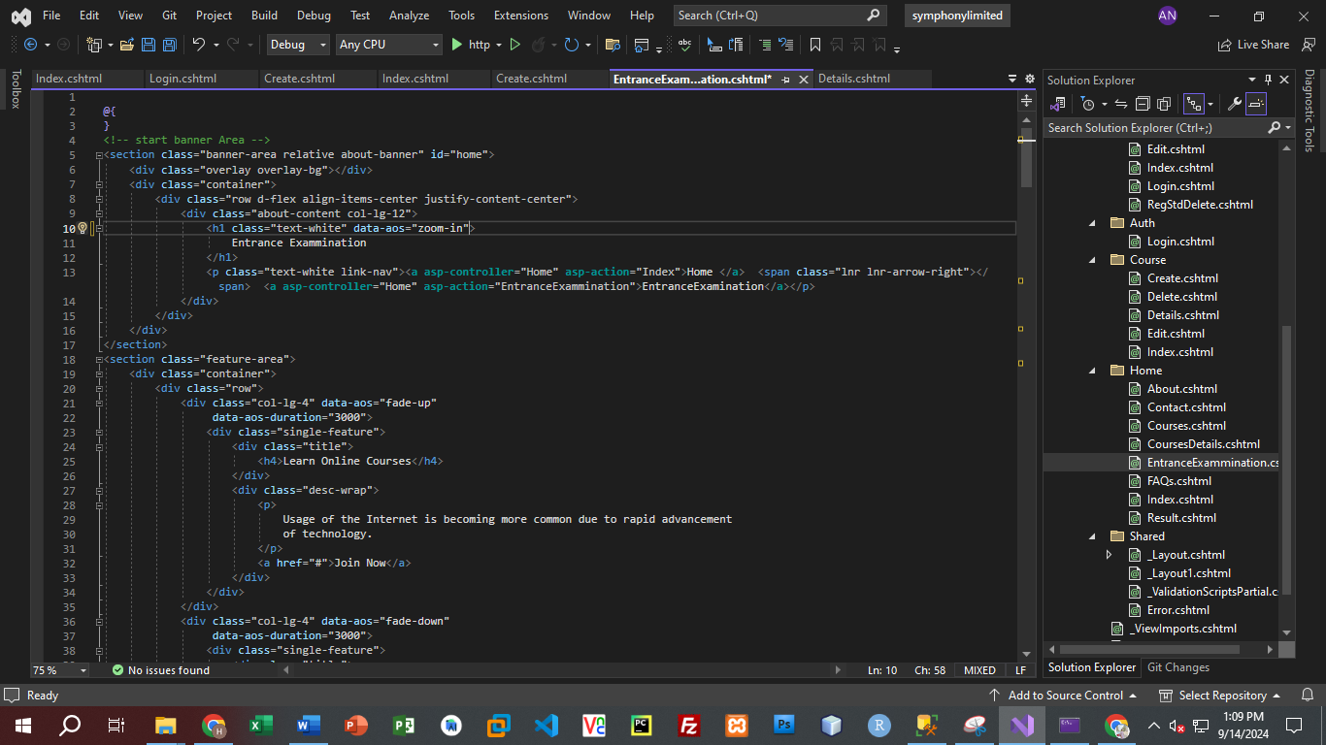

**FAQ**

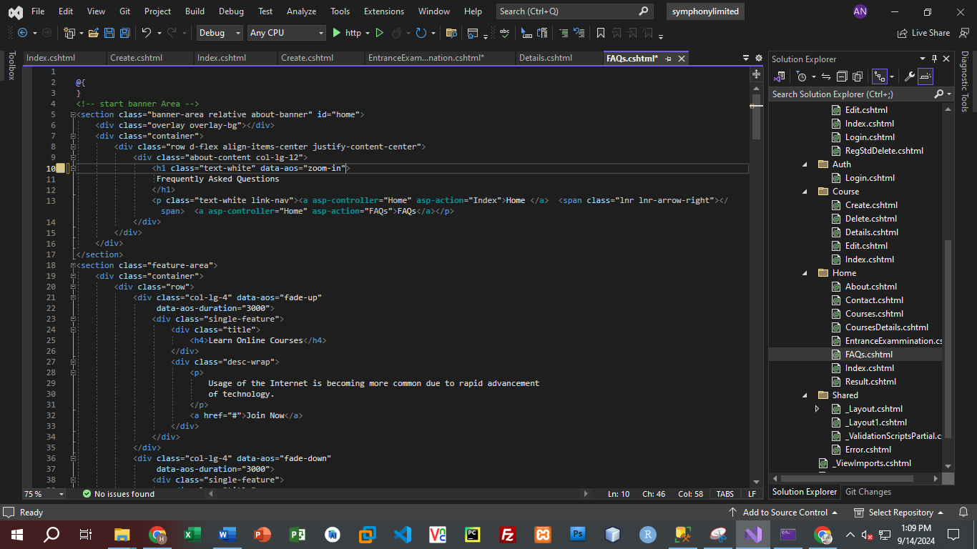

**CONTACT**

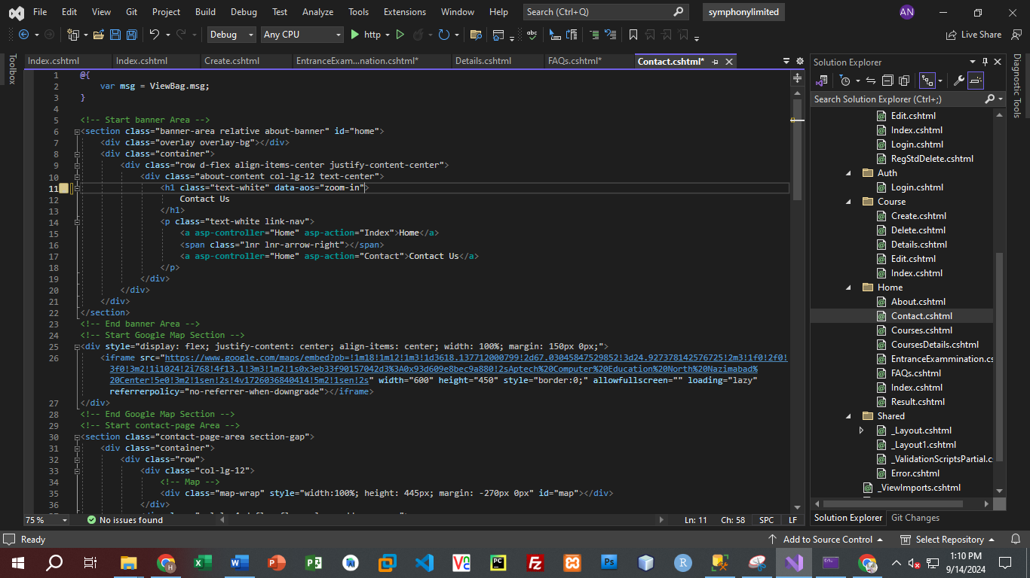

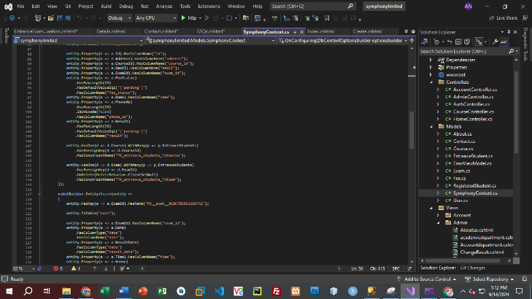**DATABASE CONNECTION**

